

2011 Air Quality Progress Report
for
Strabane District Council

In fulfillment of the Environment (Northern Ireland) Order 2002 - Local Air Quality Management

Date: May 2011

Local Authority Officer | Alan Haire

Department | Environmental Health Department
Address | Strabane District Council, 47 Derry Road, Strabane, Co Tyrone,  BT82 8DY
Telephone | 02871381311
e-mail | ahaire@strabanedc.com

Report  Reference number | Air Quality Progress Report
Date | May 2011

Executive Summary
The Air Quality Strategy for England, Scotland, Wales & Northern Ireland provides a framework for air quality control through air quality management and air quality standards. These and other air quality standards and their objectives have been enacted through the Air Quality Regulations (Northern Ireland) 2003 in Northern Ireland. The Environment (Northern Ireland) Order 2002 requires District Councils to undertake air quality reviews and assessments. In areas where the air quality objectives are not anticipated to be met by the specified dates, District Councils are required to establish Air Quality Management Areas as a means to improve air quality.
In previous rounds of the review and assessment process Strabane District Council declared 3 air quality management areas affecting Strabane, Newtownstewart and Castlederg in relation to exceedences of the air quality objectives for particles (PM₁₀). All three AQMA’s remain in force and have been supplemented by the declaration of 3 overlying smoke control areas in order to control domestic emissions from solid fuel combustion.

This progress report provides an update as to the prevailing conditions within the Strabane District Council area and identifies any relevant changes to the air quality across the district. The conclusion of the report is that no detailed assessment is currently required for any pollutant prescribed for local authority control.

Table of contents
1 Introduction 1
1.1 Description of Local Authority Area 1
1.2 Purpose of Progress Report 1
1.3 Air Quality Objectives 2
1.4 Summary of Previous Review and Assessments 4
2 New Monitoring Data 7
2.1 Summary of Monitoring Undertaken 7
2.2 Comparison of Monitoring Results with Air Quality Objectives 8
3 New Local Developments 11
3.1 Road Traffic Sources 11
3.2 Other Transport Sources 12
3.3 Industrial Sources 12
3.4 Commercial and Domestic Sources 12
3.5 New Developments with Fugitive or Uncontrolled Sources 12
4 Local/Regional Air Quality Strategy 13
5 Planning Applications 13
6 Air Quality Planning Policies 13
7 Local Transport Plans and Strategies 13
8 Climate Change Strategies 13
9 Implementation of Action Plans 13
10 Conclusions and Proposed Actions 17
10.1 Conclusions from New Monitoring Data 17
10.2 Conclusions relating to New Local Developments 17
10.3 Proposed Actions 17
11 References 18

Appendices

Appendix 1 QA/QC Data

List of Tables

Table 1.1 Air Quality Objectives included in Regulations for the purpose of Local Air Quality Management in Northern Ireland

Table 2.1 Details of Automatic Monitoring Sites

Table 2.2 Results of PM₁₀ Automatic Monitoring: Comparison with Annual Mean Objective

Table 2.3 Results of PM₁₀ Automatic Monitoring: Comparison with 24-hour Mean Objective

Table 2.4 Results of SO₂ Automatic Monitoring: Comparison with Objectives

Table 2.5 Results of SO₂ Automatic Monitoring: Comparison with 24-hour Mean Objective

Table 2.6 Results of SO₂ Automatic Monitoring: Comparison with 1-hour Mean Objective

Table 2.7 Results of SO₂ Automatic Monitoring: Comparison with 15- minute Mean Objective
Table 5.1 Action Plan Progress

List of Figures

Figure 1.1 Map of Strabane AQMA Boundary
Figure 1.2 Map of Castlederg AQMA Boundary
Figure 1.3 Map of Newtownstewart AQMA Boundary
Figure 2.1 Map of Springhill Park Automatic Monitoring Site

Introduction

Description of Local Authority Area
The Strabane District Council area comprises some 922 square kilometres of largely unspoilt countryside, and is situated in north-west County Tyrone, Northern Ireland on the border with County Donegal in the Republic of Ireland. The principal centres of population are shown in pictorial form below.

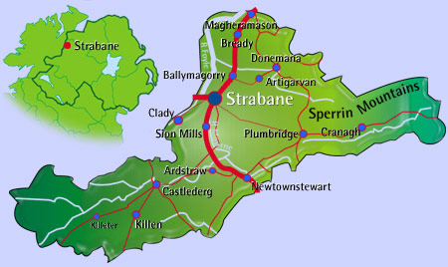

The district had a population of 38,248 (NI Census) in 2001, the largest proportion of which reside in the main population centres of Strabane town and smaller towns of Castlederg and Newtownstewart. A number of small villages also exist within the district.

Strabane is situated approximately 14 miles from Derry/Londonderry and 90 miles from Belfast. The principal traffic routes within the district are the A5 (currently carrying approximately 14020 vehicles per day through Strabane which spans from Ballygawley to Derry/Londonderry via Newtownstewart and is a main arterial route), and the A38 (currently carrying approximately 19530 vehicles per day which links Strabane with Co Donegal in the Republic of Ireland). Strabane is linked to the smaller towns of Castlederg by the B72, Donemana by the B49 and Plumbridge by the B526; these roads carrying substantially less vehicles per day than the other traffic routes.

Purpose of Progress Report
Progress Reports are required in the intervening years between the three-yearly Updating and Screening Assessment reports. Their purpose is to maintain continuity in the Local Air Quality Management process.

They are not intended to be as detailed as Updating and Screening Assessment Reports, or to require as much effort. However, if the Progress Report identifies the risk of exceedence of an Air Quality Objective, the Local Authority (LA) should undertake a Detailed Assessment immediately, and not wait until the next round of Review and Assessment.

1.3 Air Quality Objectives
The air quality objectives applicable to LAQM in Northern Ireland are set out in the Air Quality Regulations (Northern Ireland) 2003, Statutory Rules of Northern Ireland 2003, No. 342, and are shown in Table 1.1. This table shows the objectives in units of microgrammes per cubic metre μg/m³ (milligrammes per cubic metre, mg/m³ for carbon monoxide) with the number of exceedences in each year that are permitted (where applicable).

Table 1.1 Air Quality Objectives included in Regulations for the purpose of Local Air Quality Management in Northern Ireland.

Pollutant |  |  | Date to be achieved by
Pollutant | Concentration | Measured as | Date to be achieved by
Benzene | 16.25 µg/m³ | Running annual mean | 31.12.2003
Benzene | 3.25 µg/m³ | Running annual mean | 31.12.2010
1,3-Butadiene | 2.25 µg/m³ | Running annual mean | 31.12.2003
Carbon monoxide | 10.0 mg/m³ | Running 8-hour mean | 31.12.2003
Lead | 0.5 µg/m³ | Annual mean | 31.12.2004
Lead | 0.25 µg/m³ | Annual mean | 31.12.2008
Nitrogen dioxide | 200 µg/m³ not to be exceeded more than 18 times a year | 1-hour mean | 31.12.2005
Nitrogen dioxide | 40 µg/m³ | Annual mean | 31.12.2005
Particles (PM₁₀) (gravimetric) | 50 µg/m³, not to be exceeded more than 35 times a year | 24-hour mean | 31.12.2004
Particles (PM₁₀) (gravimetric) | 40 µg/m³ | Annual mean | 31.12.2004
Sulphur dioxide | 350 µg/m³, not to be exceeded more than 24 times a year | 1-hour mean | 31.12.2004
Sulphur dioxide | 125 µg/m³, not to be exceeded more than 3 times a year | 24-hour mean | 31.12.2004
Sulphur dioxide | 266 µg/m³, not to be exceeded more than 35 times a year | 15-minute mean | 31.12.2005

1.4 Summary of Previous Review and Assessments

Strabane District Council has now completed the second round of the review and assessment process. The findings of the review and assessment identified exceedences of the air quality objectives for particles (PM₁₀) resulting from domestic emissions. Three air quality management areas affecting Strabane, Newtownstewart and Castlederg became effective on 30th June 2004 and an action plan was developed in order to identify measures to reduce ambient concentrations of particles and attempt to comply with the objectives for particles (PM₁₀).

Strabane District Council has also completed updating and screening assessments in 2006 and 2009 which did not highlight any other areas of concern and that required a detailed assessment to be undertaken.

Figure 1.1 Map of Strabane AQMA Boundary

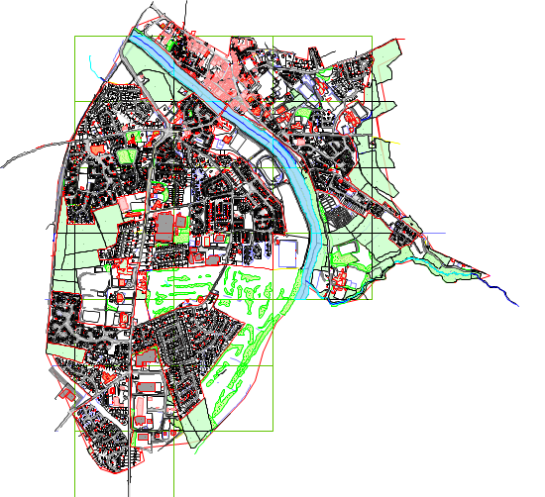

Figure 1.2 Map of Castlederg AQMA Boundary

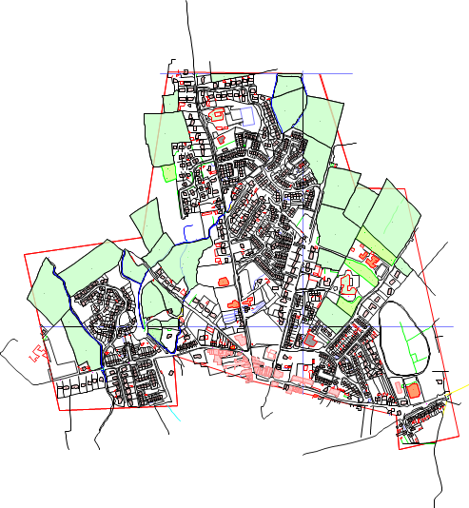

Figure 1.3 Map of Newtownstewart AQMA Boundary

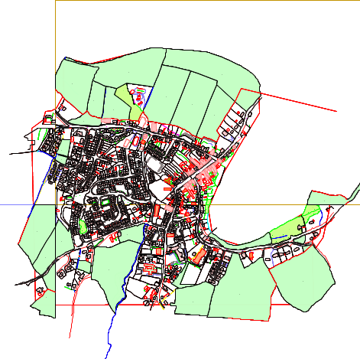

New Monitoring Data

Summary of Monitoring Undertaken

Automatic Monitoring Sites

Strabane District Council continues to operate a combined PM₁₀/sulphur dioxide monitoring station at Springhill Park, Strabane as illustrated in Figure 2.1 below. The site is surrounded by housing (representing the worst case location) and has been in operation since April 2002. The PM₁₀ monitoring is carried out using a Met One BAM1020 and an API M100A fluorescent analyser is used to measure the sulphur dioxide concentrations. The site is subject to independent QA/QC audits by AEA Energy & Environment at 6 monthly intervals in order to provide confidence in the procedures adopted by Strabane District Council in managing the site and to enable the data ratification process to take place. Data management services are also provided by AEA Energy & Environment. The sulphur dioxide monitoring station is subject to calibration at 2-weekly intervals by staff from Strabane District Council with the results forwarded to AEA who carry out the data validation and ratification on behalf of Strabane District Council. The BAM monitor data is subject to the recommended correction factor of 0.83333 in order to provide gravimetric equivalent data.

Figure 2.1 Map of Springhill Park Automatic Monitoring Site

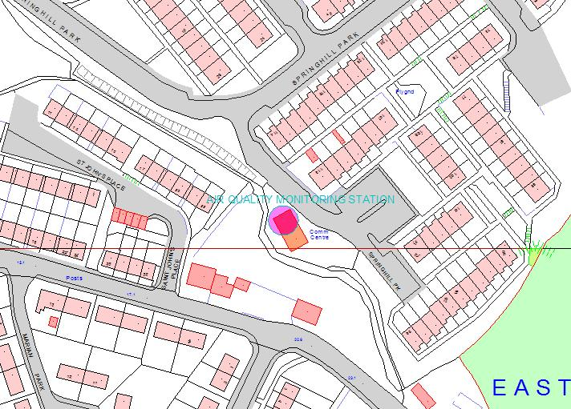

Table 2.1 Details of Automatic Monitoring Sites
Site Name | Site Type | OS Grid Ref | Pollutants Monitored | In AQMA? | Relevant  Exposure? | Distance to kerb of nearest road | Does this location represent worst-case exposure?
Springhill Park, Strabane | Urban background | 2351  3972 | PM10  SO₂ | Y | Yes (1m) | 1m | Y

Non-Automatic Monitoring
No non-automatic monitoring takes place within the Strabane District Council area.

Comparison of Monitoring Results with Air Quality Objectives

Nitrogen Dioxide
No nitrogen dioxide monitoring takes place within the Strabane District Council area.

PM₁₀
Tables 2.2 and 2.3 below provides a direct comparison of the monitoring results from the Springhill Park site with the relevant air quality objectives for PM₁₀ in 2010. The number of exceedences of the daily mean PM₁₀ objective was 17 and the annual mean was 23µg/m³ indicative gravimetric equivalent. Both air quality objectives are therefore being achieved and there is no risk of the objectives being exceeded at present. The monitoring site is located within an AQMA and represents relevant public exposure locations for domestic and transport sources of particles due to its location within a built up residential area.

Table 2.2 Results of PM₁₀ Automatic Monitoring: Comparison with Annual Mean Objective

Location | Within AQMA? | Relevant public exposure?  Y/N | Data Capture for monitoring period  % | Data Capture for full calendar year  2010  % | Annual mean concentrations (μg/m³)
 |  |  |  |  | 2006 | 2007 | 2008 | 2009 | 2010
Springhill Park  Strabane | Yes | Yes | 93.5 | 93.5 | 17 | 17 | 17 | 22 | 23

Table 2.3 Results of PM₁₀ Automatic Monitoring: Comparison with 24-hour Mean Objective

Location | Within AQMA? | Relevant public exposure?  Y/N | Data Capture for monitoring period  % | Data Capture for full calendar year  2010  % | Number of Exceedences of daily mean objective  (50 μg/m³)
 |  |  |  |  | 2006 | 2007 | 2008 | 2009 | 2010
Springhill Park  Strabane | Yes | Yes | 93.5 | 93.5 | 2 | 3 | 3 | 7 | 17

Sulphur Dioxide

Tables 2.4 to 2.7 below provides a direct comparison of the monitoring results from the Springhill Park site with the relevant air quality objectives for sulphur dioxide in 2010. There were no exceedences of any of the air quality objectives for this pollutant since monitoring began in April 2002 and this continues to be the case. All air quality objectives for this pollutant are therefore being achieved and there is no risk of the objectives being exceeded at present. The monitoring site is located within an AQMA (in relation to PM10) and represents relevant public exposure locations for a range of sources of sulphur dioxide due to its siting within a built up residential area.

Table 2.4 Results of SO₂ Automatic Monitoring: Comparison with Objectives

Location | Within  AQMA AQMA? | Relevant public exposure?  Y/N | Data Capture for monitoring period  % | Data  Capture  2010  % | Number of Exceedences of: (μg/m³)
 |  |  |  |  | 15-minute Objective  (266 μg/m³) | 1-hour Objective  (350 μg/m³) | 24-hour Objective  (125 μg/m³)
Springhill P  Park,  Strabane | Yes | Yes | 94.9 | 94.9 | 0 | 0 | 0

Table 2.5 Results of SO₂ Automatic Monitoring: Comparison with 24-hour Mean Objective

Location | Within AQMA? | Relevant public exposure?  Y/N | Data Capture for monitoring period  % | Data Capture for full calendar year  2010  % | Number of Exceedences of 24 hour mean objective  (125 μg/m³)
 |  |  |  |  | 2006 | 2007 | 2008 | 2009 | 2010
Springhill Park  Strabane | Yes | Yes | 94.9 | 94.9 | 0 | 0 | 0 | 0 | 0

Table 2.6 Results of SO₂ Automatic Monitoring: Comparison with 1-hour Mean Objective

Location | Within AQMA? | Relevant public exposure?  Y/N | Data Capture for monitoring period  % | Data Capture for full calendar year  2010  % | Number of Exceedences of 1- hour mean objective  (350 μg/m³)
 |  |  |  |  | 2006 | 2007 | 2008 | 2009 | 2010
Springhill Park  Strabane | Yes | Yes | 94.9 | 94.9 | 0 | 0 | 0 | 0 | 0

Table 2.7 Results of SO₂ Automatic Monitoring: Comparison with 15- minute Mean Objective

Location | Within AQMA? | Relevant public exposure?  Y/N | Data Capture for monitoring period  % | Data Capture for full calendar year  2010  % | Number of Exceedences of 15 minute mean objective  (266 μg/m³)
 |  |  |  |  | 2006 | 2007 | 2008 | 2009 | 2010
Springhill Park  Strabane | Yes | Yes | 94.9 | 94.9 | 0 | 0 | 0 | 0 | 0

Benzene
No monitoring for benzene takes place within the Strabane District Council area.

Other pollutants monitored
No monitoring for other pollutants takes place within the Strabane District Council area.

Summary of Compliance with AQS Objectives

Strabane District Council has examined the results from monitoring in the district. Concentrations are all below the objectives, therefore there is no need to proceed to a Detailed Assessment.

New Local Developments

Road Traffic Sources
Strabane District Council confirms that there are no new or newly identified road traffic sources which may have an impact on air quality within the Local Authority area, other than the A5 Western Transport Corridor referred to in the 2009 updating and screening assessment. A public enquiry is to be held in relation to this road scheme in 2011 and if approved further consideration will be given to the potential impact of the scheme on local air quality in future updating and screening assessments and/or progress reports as appropriate.

Other Transport Sources
Strabane District Council confirms that there are no new or newly identified non-road traffic sources which may have an impact on air quality within the Local Authority area.

Industrial Sources
Strabane District Council confirms that there are no new or newly identified industrial sources which may have an impact on air quality within the Local Authority area.

Commercial and Domestic Sources
Strabane District Council confirms that there are no new or newly identified commercial and domestic sources which may have an impact on air quality within the Local Authority area.

New Developments with Fugitive or Uncontrolled Sources
Strabane District Council confirms that there are no new or newly identified developments with fugitive or uncontrolled sources which may have an impact on air quality within the Local Authority area.

Strabane District Council confirms that there are no new or newly identified local developments which may have an impact on air quality within the Local Authority area.

Local/Regional Air Quality Strategy
Strabane District Council has not prepared a local air quality strategy and has not participated in the preparation of a regional air quality strategy.

Planning Applications
The Environmental Health Department of Strabane District Council dealt with approximately 255 planning consultations during 2010. The majority of such consultations related to single one-off dwellings as is commonplace in a rural district such as Strabane District Council. However there were a number of consultations in relation to larger housing developments, sand and gravel quarries and other commercial development. The Environmental Health Department continues to assess the potential impact of such developments on local air quality and makes recommendations to Planning Service accordingly, particularly where developments are within or adjoining existing Air Quality Management Areas. Recommendations are also made to the Industrial Pollution and Radiochemical Inspectorate of the Northern Ireland Environment Agency in relation to existing or proposed industrial processes controlled under the Pollution Prevention and Control Regulations (NI) 2003.

Air Quality Planning Policies
Strabane District Council has not prepared any air quality planning policies.

Local Transport Plans and Strategies
Strabane District Council has not prepared any local transport plans and strategies.

Climate Change Strategies
Strabane District Council has not prepared a climate change strategy.

Implementation of Action Plans
Strabane District Council continues to promote and implement the measures included in the air quality action plan agreed in 2005 as outlined in Table 5.1 below. All elements of the action plan are currently being progressed, particularly the implementation of smoke control areas as this is deemed necessary in reducing domestic emissions of PM₁₀. The first smoke control area in Strabane came into operation on 30th April 2007. The remaining two smoke control areas became effective from 30 September 2007 in Castlederg and Newtownstewart. In addition two schemes have been implemented in conjunction with Northern Ireland Electricity which have replaced approximately 170 solid fuel appliances in owner-occupied and privately rented properties. A significant number of properties were also referred to the Warm Homes Scheme funded by the Department for Social Development. The NIHE heating conversion scheme is now complete with the exception of approximately 14 isolated rural dwellings.
The Environmental Health Department continues to refer private households and private landlords to the NIHE housing grants section. New responsibilities for district councils contained in the Private Tenancies (NI) Order 2006 have facilitated access to such landlords thereby targeting eligible households more effectively. Whilst not initially contained in the air quality action plan, Big Lottery funding has been secured to implement the Western Home Environmental Assessment Project (WHEAP) for a period of 5 years from November 2009. This project is targeted at vulnerable homes with persons aged 65 years and over and those with children under 5 years. The project includes assessment of a range of matters including fuel poverty and energy efficiency. The project is also a referral agency for the DSD Warm Homes Scheme and thereby provides continuity in improving the energy efficiency of such homes and reducing emissions of PM₁₀. Strabane District Council has also engaged in an interagency working group on bonfires in order to reduce the number of such activities across the district. The findings report of the working group was formally launched in February 2011. This will hopefully assist in the reduction of emissions of air pollutants from this source.

Table 5.1 below demonstrates the continuing nature and ongoing commitment of Strabane District Council to maintain and where possible improve air quality within the district with particular emphasis on domestic sources of particles. As demonstrated by the 2009 PM₁₀ monitoring data and that of previous years it appeared that the degree of effectiveness had been achieved for the air quality action plan as demonstrated by the annual mean PM₁₀ concentration and the small number of exceedences of the daily mean air quality objective in each of the previous 4 years. A slight increase in the annual mean and daily objective exceedences was experienced in the 2009 calendar year and this increase has been repeated during 2010. Factors thought to be involved in this increase in PM₁₀ concentrations are the severe cold weather experienced in the winter months, an increase in the price of domestic heating oil, fuel poverty considerations and reluctance of householders to use smokeless fuels. It is considered that the air quality at Springhill Park represented the highest area of exceedence in previous rounds of review and assessment and this was the area selected for the continuous monitoring site. Other areas of the district were and are still considered to represent a lower risk of the air quality objectives being exceeded and it is submitted that the Springhill Park air quality monitoring site is representative. The air quality objectives for PM₁₀ are therefore expected to be achieved at all locations within the Strabane District Council area.

Table 5.1 Action Plan Progress
No. | Measure | Focus | Lead authority | Planning phase | Implementation phase | Indicator | Target annual emission reduction in the AQMA | Progress to date | Progress in last 12 months | Estimated completion date | Comments relating to emission reductions
1 | Implement  smoke  Control  areas:  Strabane  Newtown-  stewart  Castlederg | Domestic emissions | Strabane District Council | Complete | Complete/ongoing | Reduced coal burning | None | Air quality objectives achieved | Ongoing compliance monitoring & compliance maintained | Complete & ongoing monitoring | Substantial emissions reductions achieved
2 | NIHE  Conversion Schemes | Domestic emissions | NIHE | Complete | Complete | Reduced coal burning | None | Substantial majority of homes provide with OFCH | Additional homes provided with OFCH | 2010 | Substantial emissions reductions achieved
3 | Warm Homes Scheme  Promotion | Domestic  emissions | Strabane District Council | Complete | Ongoing | Reduced solid fuel burning | None | Referrals made to Warm Homes | Continued referrals to Warm Homes. WHEAP project initiated | Ongoing referrals. WHEAP funded for 5 years | Complimentary  Emissions reductions achieved
4 | Energy  Efficiency Promotion | Domestic emissions | Strabane District Council | Complete | Ongoing | Reduced emissions | None | 2 NIE Energy Efficiency Schemes complete, routine referrals to EST Advice Line. WHEAP project initiated | WHEAP project initiated, Continued referrals to EST | Ongoing

5 | Planning Controls | Domestic & commercial/  industrial emissions | Planning Service | Complete | Ongoing | Informatives placed on planning approvals | None | Ongoing | Comments made routinely on relevant planning applications. Raised at regional planning liaison meetings | Ongoing | Some developments constructed without solid fuel heating systems
6 | Bonfire Guidance and Controls | Commercial  emissions | Strabane District Council | Complete | Ongoing | Reduced detections of illegal burning | None | Ongoing | Reduced number of detections. Bonfire working group established with NIEA/NIHE/NIFRS & Strabane District Council | Ongoing

Conclusions and Proposed Actions

Conclusions from New Monitoring Data
No exceedences of the air quality objectives have been identified, within and outside of existing AQMA’s. New monitoring data has identified an upward trend in PM10 concentrations during 2010, although the air quality objectives are not currently at risk of being exceeded. No new monitoring has been undertaken that would identify any potential or actual exceedences at relevant locations outside existing AQMAs. All monitoring results within AQMA’s are below the air quality objectives.

Conclusions relating to New Local Developments
There are currently no new local developments that require detailed assessment. This situation will be reviewed in the next Updating and Screening Assessment.

Proposed Actions
It is proposed to submit a further action plan progress report and updating and screening assessment in 2012.

References

Strabane District Council Stage 1 Review and Assessment 2000
Strabane District Council Stage 2/3 Review and Assessment 2004
Strabane District Council Air Quality Action Plan 2005
Strabane District Council Updating and Screening Assessment 2006
Strabane District Council Updating and Screening Assessment 2009
Appendices
Appendix 1: QA:QC Data

PM Monitoring Adjustment

PM10 monitoring data from the BAM is corrected to gravimetric equivalent using a factor of 0.83333 for Indicative Gravimetric Equivalence.

QA/QC of automatic monitoring

AEA carry out independent QA/QC visits to the Springhill Park monitoring station at 6-monthly intervals. Strabane District Council carries out calibrations of the sulphur dioxide monitor at 2-weekly intervals.

