
Causeway Coast and Glens Borough Council
2025 Air Quality Progress Report
In fulfilment of Environment (Northern Ireland) Order 2002
Local Air Quality Management
June 2025
Information | Causeway Coast and Glens Borough Council
Local Authority Officer | Sharon McAfee
Department | Health and Built Environment
Address | Riada House Ballymoney
Telephone | 028 2766 0257
E-mail | environmentalhealth@causewaycoastandglens.gov.uk
Report Reference Number | PR 25 Report
Date | June 2025

Executive Summary
The new Council of Causeway Coast and Glens Borough Council was formed under Local Government Reform on 1st April 2015, merging Legacy Councils; Ballymoney, Coleraine, Limavady and Moyle.
Within the Borough of Causeway Coast and Glens monitoring of nitrogen dioxide (NO₂) has been undertaken since 2008. This monitoring was undertaken as a result of desktop and stage 1 assessments carried out in the preceding years. Nitrogen dioxide from traffic emissions was identified as a significant pollutant which required detailed investigation.
An Air Quality Management Area (AQMA) was declared within the legacy Limavady District Council, along Dungiven Main Street, in 2009 as levels were in excess of the annual mean concentration of 40µg/m³.
A continuous automatic monitor was installed along Main Street on 4th August 2010 in order to monitor Nitrogen dioxide pollutant concentrations. This has since been replaced with a new NO_{x} monitor and a new PM10 + PM2.5 monitor has been installed alongside this. See below.
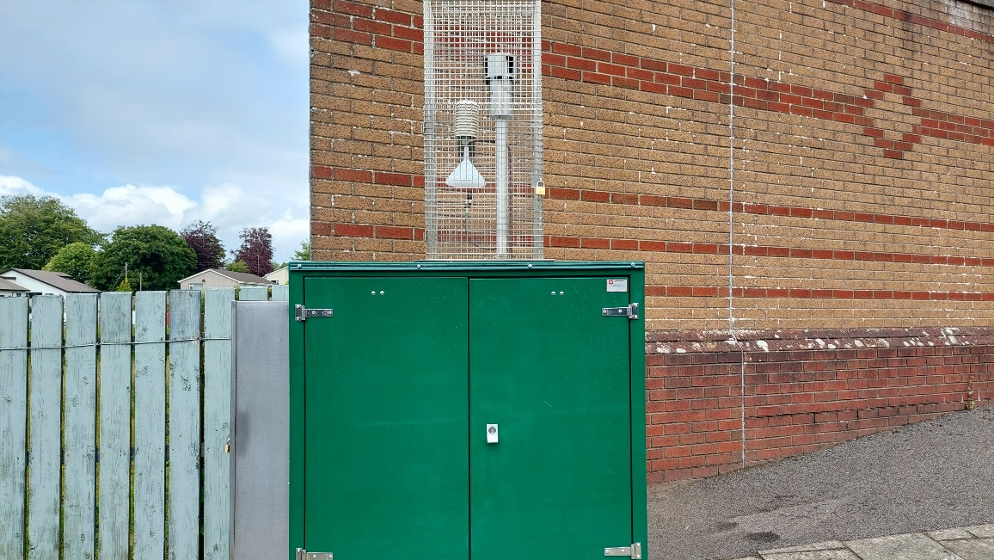
Passive monitoring has been undertaken in other legacy Council locations within the Borough to ensure that levels did not increase.
This report details the air quality information/data gathered by Causeway Coast and Glens Borough Council within the year 2024 and compares it with air quality pollutant levels obtained in previous years as far back as 2014.
Whilst there have been difficulties with the automatic monitoring site due to intermittent mechanical malfunctions in 2021, passive monitoring data derived has shown that levels have remained constant if not, in some cases, slightly reduced on last year.
It is assumed that the 2020 & 2021 data may have been influenced by COVID restrictions on travel. Full monitoring recommenced in 2022.
The action plan derived by legacy Limavady Borough Council, now Causeway Coast and Glens Borough Council, had identified the only long-term solution to the elevated levels due to road traffic within the Dungiven AQMA as being the construction of a bypass in Dungiven.
This bypass has been alluded to for decades, and up until 2018 no progress had been made. The bypass was to form part of a wider dualling scheme of the A6 from Drumahoe to Dungiven, but financial constraints up until then had meant that the project was delayed.
The bypass scheme was completed in April 2023.
In previous reports it was documented that most of the traffic going through Dungiven was through traffic. These vehicles did not stop in the town to access businesses or dwellings. Local traffic only accounted for a small proportion of the daily volumes.
It is envisaged that the bypass will divert through traffic, a significant percentage of which are HGV’s, away from the town, and that significant improvements in air quality will be achieved.
Monitoring will continue within the existing AQMA. Causeway Coast and Glens Borough Council has committed to undertaking further air quality monitoring by installing a Palas Fidas PM10 + 2.5 monitor and replaced the existing NO_{x} monitor with a new monitor.
Passive monitoring in the other main urban areas of the Borough was discontinued in 2019, following the publication of the report entitled “Passive Diffusion Monitoring of NO₂ within Causeway Coast and Glens Borough Council 2014-2018” (Appendix B).
Analysis of the NO₂ data at the passive monitoring sites throughout the Borough over the period 2014 – 2018 showed that concentrations were below the applicable annual mean objective level at the legacy monitoring locations in Ballymoney Borough Council, Moyle District Council and Coleraine Borough Council areas.
From the passive diffusion data derived, results showed the levels were below the annual mean concentration of 40µg/m³.
However, the annual mean objective level of 40ug/m³ continued to be exceeded during this period (2014-2018) at two passive monitoring sites within the Dungiven AQMA. These two discontinued legacy sites (locations C and G) correspond with junctions which lead onto Main Street, Dungiven.

No further detailed assessments have been deemed necessary to evaluate air quality within the Borough. This will be reviewed in the next Progress Report, or if Council become aware of any new developments which have the potential to adversely impact air quality.
It is also valuable to review and update air quality within the Borough as part of this department’s remit under the legislation (Part III of the Environment (Northern Ireland) Order 2002, the Air Quality Standards Regulations (Northern Ireland) 2010 and the Air Quality Regulations (Northern Ireland) 2003.

Table of Contents
Executive Summary ii
1 Introduction 1
1.1 Description of Local Authority Area 1
1.2 Purpose of Progress Report 1
1.3 Air Quality Objectives 2
1.4 Summary of Previous Review and Assessments 3
2 New Monitoring Data 5
2.1 Summary of Monitoring Undertaken 5
2.1.1 Automatic Monitoring Sites 5
2.1.2 Non-Automatic Monitoring Sites 7
2.2 Comparison of Monitoring Results with Air Quality Objectives 11
2.2.1 Nitrogen Dioxide (NO₂) 11
2.2.2 Particulate Matter (PM₁₀) 20
2.2.3 Sulphur Dioxide (SO₂) 20
2.2.4 Benzene 20
2.2.5 Other Pollutants Monitored 20
2.2.6 Summary of Compliance with AQS Objectives 20
3 New Local Developments 21
3.1 Road Traffic Sources 21
3.2 Other Transport Sources 21
3.3 Industrial Sources 21
3.4 Commercial and Domestic Sources 21
3.5 New Developments with Fugitive or Uncontrolled Sources 21
4 Planning Applications 23
5 Conclusions and Proposed Actions 24
5.1 Conclusions from New Monitoring Data 24
5.2 Conclusions relating to New Local Developments 24
5.3 Other Conclusions 25
5.4 Proposed Actions 25
6 References 26
7 Appendices 27
Appendix A: QA/QC Data 28
QA/QC Diffusion Tube Monitoring 28
Diffusion Tube Annualisation 28
Diffusion Tube Bias Adjustment Factors 28
Appendix B: Cessation of passive diffusion monitoring of NO₂ within Causeway Coast and Glens Borough Council 2014-2018 29
Appendix C: Ballykelly Air Quality Briefing 34

List of Figures
Figure 1 - Maps of AQMA Boundaries 3
Figure 2 – Map(s) of Automatic Monitoring Sites 4
Figure 3 - Map(s) of Non-Automatic Monitoring Sites 7
Figure 4 – Trends in Annual Mean NO2 Concentrations Measured at Automatic Monitoring Sites 12
Figure 5 – Trends in Annual Mean Nitrogen Dioxide Concentrations Measured at Diffusion Tube Monitoring Sites 18

List of Tables
Table 1 – Air Quality Objectives included in Regulations for the purpose of LAQM in Northern Ireland 1
Table 2 – Details of Automatic Monitoring Sites 6
Table 3 – Details of Non-Automatic Monitoring Sites 9
Table 4 - Monthly Data Captures 2024 (%) 11
Table 5 – Results of Automatic Monitoring for NO₂: Comparison with Annual Mean Objective 12
Table 6 – Results of Automatic Monitoring for NO₂: Comparison with 1-hour Mean Objective 14
Table 7 – Annual Results Summary 15
Table 8 – Results of NO₂ Diffusion Tubes (2018 to 2024) 17

Appendices
Appendix A: Quality Assurance / Quality Control (QA/QC) Data
Appendix B: Cessation of passive diffusion monitoring of NO₂ within Causeway Coast and Glens Borough Council 2014-2018

Appendix C: Ballykelly Air Quality Briefing

Introduction

Description of Local Authority Area
Causeway Coast and Glens Borough Council is located along the North and East coasts of Northern Ireland and encompasses the former Councils of Ballymoney, Coleraine, Limavady and Moyle. From the 2021 Northern Ireland Census data, it has a population of just over 141,746 residents (NISRA, 2022).
The land area is approximately 2000km².
The council area is a mix of market towns, commercial, small industrial hubs, and open countryside.
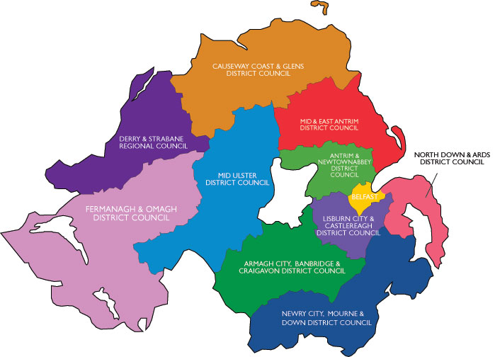

Purpose of Progress Report
This report fulfils the requirements of the Local Air Quality Management (LAQM) process as set out in the Environment (Northern Ireland) Order 2002, the Air Quality Strategy for England, Scotland, Wales and Northern Ireland 2007 and the relevant Policy and Technical Guidance documents. The LAQM process places an obligation on all local authorities to regularly review and assess air quality in their areas, and to determine whether or not the air quality objectives are likely to be achieved. Where exceedances are considered likely, the local authority must then declare an Air Quality Management Area (AQMA) and prepare an Air Quality Action Plan (AQAP) setting out the measures it intends to put in place in pursuit of the objectives.
For Local Authorities in Northern Ireland, Progress Reports are required in the intervening years between the three-yearly Updating and Screening Assessment reports. Their purpose is to maintain continuity in the LAQM process.
They are not intended to be as detailed as Updating and Screening Assessment Reports, or to require as much effort. However, if the Progress Report identifies the risk of exceedance of an Air Quality Objective, the Local Authority (LA) should undertake a Detailed Assessment immediately, and not wait until the next round of Review and Assessment.

Air Quality Objectives
The air quality objectives applicable to LAQM in Northern Ireland are set out in the Air Quality Regulations (Northern Ireland) 2003, Statutory Rules of Northern Ireland 2003, no. 342, and are shown in Table 1. This table shows the objectives in units of microgrammes per cubic metre µg/m³ (milligrammes per cubic metre, mg/m³ for carbon monoxide) with the number of exceedances in each year that are permitted (where applicable)

Table 1 – Air Quality Objectives included in Regulations for the purpose of LAQM in Northern Ireland
Pollutant | Air Quality Objective |  | Date to be achieved by
Pollutant | Concentration | Measured as | Date to be achieved by
Benzene | 16.25 µg/m³ | Running annual mean | 31.12.2003
Benzene | 3.25 µg/m³ | Running annual mean | 31.12.2010
1,3-butadiene | 2.25 µg/m³ | Running annual mean | 31.12.2003
Carbon monoxide | 10 mg/m³ | Running 8-hour mean | 31.12.2003
Lead | 0.50 µg/m³ | Annual mean | 31.12.2004
Lead | 0.25 µg/m³ | Annual mean | 31.12.2008
Nitrogen dioxide | 200 µg/m³ not to be exceeded more than 18 times a year | 1-hour mean | 31.12.2005
Nitrogen dioxide | 40 µg/m³ | Annual mean | 31.12.2005
Particulate matter (PM₁₀) (gravimetric) | 50 µg/m³, not to be exceeded more than 35 times a year | 24-hour mean | 31.12.2004
Particulate matter (PM₁₀) (gravimetric) | 40 µg/m³ | Annual mean | 31.12.2004
Sulphur dioxide | 350 µg/m³, not to be exceeded more than 24 times a year | 1-hour mean | 31.12.2004
Sulphur dioxide | 125 µg/m³, not to be exceeded more than 3 times a year | 24-hour mean | 31.12.2004
Sulphur dioxide | 266 µg/m³, not to be exceeded more than 35 times a year | 15-minute mean | 31.12.2005

Summary of Previous Review and Assessments
Desktop assessments were carried out within legacy Councils (Ballymoney, Coleraine, Limavady and Moyle) to determine if the defined air quality pollutant levels were likely to exceed the National Air Quality Objective levels as set out within the Air Quality Regulations (NI) 2003.
Of particular interest for these Councils were nitrogen dioxide from traffic emissions, particulate matter (PM₁₀) and sulphur dioxide. Particulate matter and sulphur dioxide emissions are associated with industrial processes and the burning of fossil fuels. Following on from these desktop assessments further analysis of pollutants was carried out. Fuel use surveys, DMRB (design manual for roads and bridges) assessments and passive monitoring (nitrogen dioxide for road traffic emissions) were carried out to assess levels.
In terms of the legacy Councils, Air Quality Management Areas (AQMAs) were declared:
- Legacy Limavady Borough Council - Main Street Dungiven for nitrogen dioxide (NO₂), road traffic pollutant emission source.
- Legacy Ballymoney Borough Council - Glebeside, Ballymoney for particulates (PM₁₀), domestic fossil fuel emission source. (The Glebeside AQMA was undeclared as houses in this estate had been converted over to gas).
The AQMA within Dungiven is the only one remaining in place.
Figure 1 - Maps of AQMA Boundaries
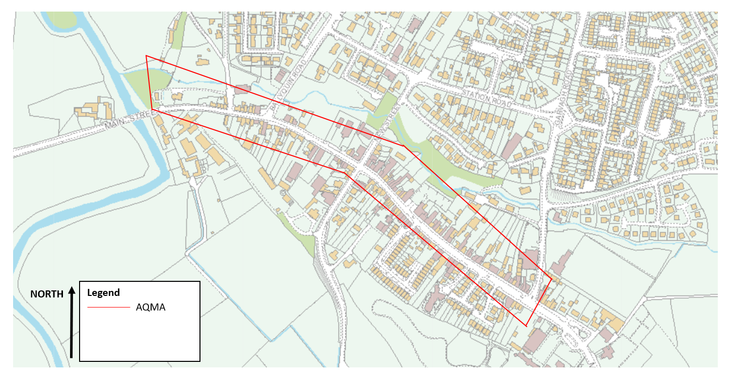

New Monitoring Data

Summary of Monitoring Undertaken

Automatic Monitoring Sites
Causeway Coast and Glens Borough Council has a continuous NO₂ monitor within the AQMA in Dungiven. It has been operational since 2010. The continuous NO₂ monitor was replaced in May 2025 with a ACOEM Serinus 40 NOx analyser. The monitor is audited and serviced on an annual basis by contractors and the data is ratified. A Palas FIDAS 200 dual channel PM10 + PM2.5 was purchased and installed at the same time.
Figure 2 – Map(s) of Automatic Monitoring Sites

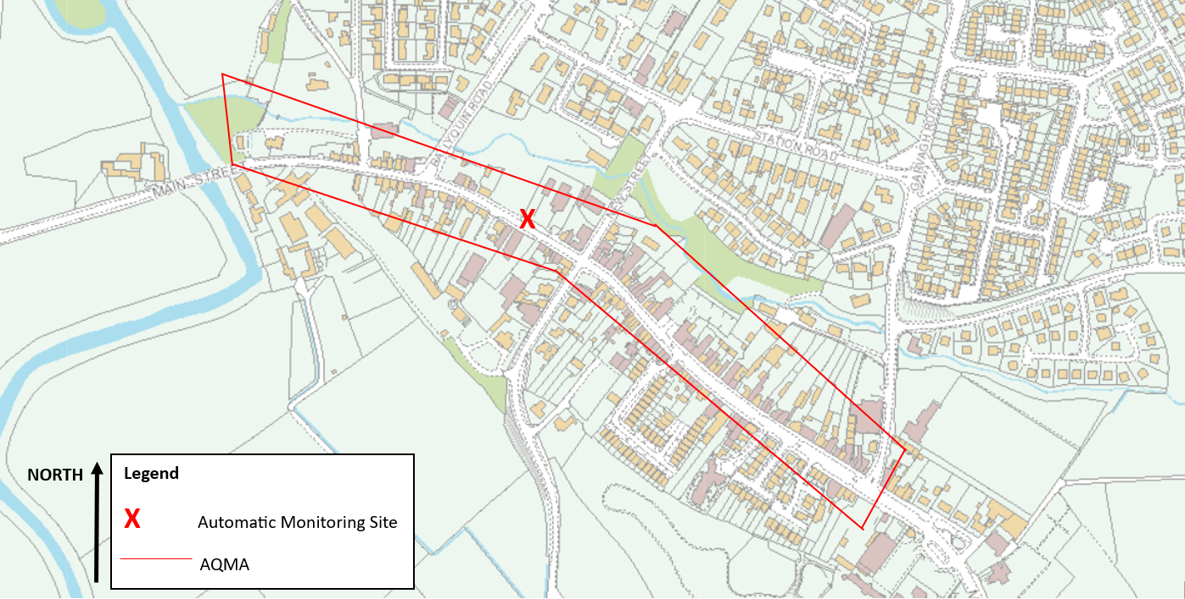
Table 2 – Details of Automatic Monitoring Sites
Site ID | Site Name | Site Type | X OS Grid Reference | Y OS Grid Reference | Inlet Height (m) | Pollutants Monitored | In AQMA? | Monitoring Technique | Relevant Exposure? (Y/N with distance (m) from monitoring site to relevant exposure) | Distance to Kerb of Nearest Road (m) (N/A if not applicable) | Does this Location Represent Worst-Case Exposure?
Dungiven AQMA | Main Street | Urban Roadside | 268851 | 409503 | 2.0 | NO₂ | Y | Chemiluminescent | Y (1m) | 1m | Y
Dungiven AQMA | Main Street | Urban Roadside | 268851 | 409503 | 2.0 | PM2.5 + PM10 | Y | Optical light scattering | Y (1m) | 1m | Y

Non-Automatic Monitoring Sites
Nitrogen dioxide (NO₂) and nitric oxide (NO) are both oxides of nitrogen and are collectively referred to as nitrogen oxides.
All combustion processes produce nitrogen oxide emissions, largely in the form of nitric oxide, which is then converted to nitrogen dioxide mainly as a result of reactions with ozone in the atmosphere.
Exposure to high concentrations of nitrogen dioxide is reported to sensitize asthmatics to allergens, such as irritant chemicals, house dust mites and pollen.
In urban areas, particularly close to major roads, motor vehicles account for the largest proportion of nitrogen oxide emissions. The contribution of road transport to nitrogen oxide emissions has declined significantly in recent years because of various national policy measures.
Diffusion tubes are a type of passive sampler; they absorb the pollutant to be monitored directly from the surrounding air. Diffusion tubes represent a simple and cost-effective method of monitoring air quality in an area, to give a good general indication of average pollution concentrations. They are particularly useful for assessment against annual mean objectives.
Monitoring sites are chosen to provide data on locations where there is relevant public exposure and where possible, are close to the nearest receptor to the busy road or road junction of interest. The sites are subject to periodic review.
Diffusion tubes are placed out in accordance with and adherence to the DEFRA – Exposure Calendar and Methodology. At the end of the monitoring period the tubes are collected, documentation completed and then sent to the appointed laboratory (Gradko Environmental) to undergo analysis.
On completion of analysis, the results are emailed to the Environmental Protection Team and are recorded for use in the results tabulation for the applicable year.
Results obtained from diffusion tube analysis require correction for possible positive bias (over-read), or negative bias (under-read). The preparation method used was an absorbent of 20% TEA (Triethanolamine) in water. The bias adjustment factor for Gradko and the technique in 2024 is 0.84. This factor is based on 33 studies and is taken from the DEFRA website at: http://laqm.defra.gov.uk/bias-adjustment-factors/national-bias.html.
Passive monitoring in Legacy Council Areas of Coleraine, Moyle and Ballymoney was discontinued in 2019, following the publication of the report entitled “Passive Diffusion Monitoring of NO₂ within Causeway Coast and Glens Borough Council 2014-2018” (Appendix B).
Figure 3 - Map(s) of Non-Automatic Monitoring Sites
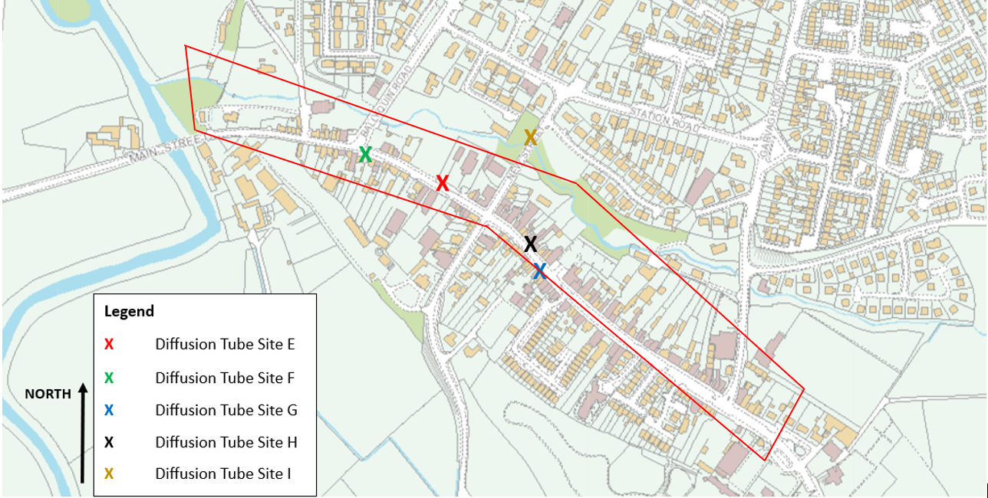

Table 3 – Details of Non-Automatic Monitoring Sites
Site ID | Site Name | Site Type | X OS Grid Reference | Y OS Grid Reference | Pollutants Monitored | In AQMA? Which AQMA? | Relevant Exposure? (Y/N with distance (m) from monitoring site to relevant exposure) | Distance to Kerb of Nearest Road (m) (N/A if not applicable) | Is Monitoring Co-located with a Continuous Analyser (Y/N) | Site Height (m)
E | Main Street (AQ Monitor) | Roadside | 268851 | 409503 | NO₂ | Y | Y (1m) | 1 | Y | 2.5
F | Main Street | Roadside | 268742 | 409543 | NO₂ | Y | Y (1m) | 1 | N | 2.5
G | Main Street | Roadside | 268981 | 409387 | NO₂ | Y | Y (1m) | 1 | N | 2.5
H | Main Street | Roadside | 269051 | 409338 | NO₂ | Y | Y (1m) | 1 | N | 2.5
I | New Street | Roadside | 268957 | 409535 | NO₂ | Y | Y (1m) | 1 | N | 2.5

Site ID | Site Name | Site Type | X OS Grid Reference | Y OS Grid Reference | Pollutants Monitored | In AQMA? Which AQMA? | Relevant Exposure? (Y/N with distance (m) from monitoring site to relevant exposure) | Distance to Kerb of Nearest Road (m) (N/A if not applicable) | Is Monitoring Co-located with a Continuous Analyser (Y/N) | Site Height (m)
A | Plantation Road | Roadside | 262706 | 422217 | NO₂ | N | Y (1m) | 1 | N | 2.5
B | Main Street | Roadside | 262903 | 422347 | NO₂ | N | Y (1m) | 1 | N | 2.5
C | Main Street | Roadside | 262774 | 422364 | NO₂ | N | Y (1m) | 1 | N | 2.5
D | Glenhead Road | Roadside | 262904 | 422246 | NO₂ | N | Y (1m) | 1 | N | 2.5

Comparison of Monitoring Results with Air Quality Objectives

Nitrogen Dioxide (NO₂)
Automatic Monitoring Data
Data is presented below for the Nitrogen Dioxide levels within the AQMA for 2022 (Table 4).
Table 4 - Monthly Data Captures 2024 (%)
Pollutant – Nitrogen Dioxide
Jan | Feb | Mar | Apr | May | Jun | Jul | Aug | Sep | Oct | Nov | Dec
99.5 | 100 | 100 | 99.4 | 90.6 | 100 | 100 | 100 | 100 | 99.6 | 79.7 | 77.4

The NO₂ annual mean was 16.2 µg/m³ for 2022. The AQS annual mean Objective is 40 µg/m³ and the target annual data capture is 75%. The NO₂ annual mean and hourly mean objectives (2024) were not exceeded. For 2024 this site achieved 95.5% data capture, therefore annualisation was not required for this data.
Table 5 – Results of Automatic Monitoring for NO2: Comparison with Annual Mean Objective
Site ID | X OS Grid Ref | Y OS Grid Ref | Site Type | Valid Data Capture for Monitoring Period % ª | Valid Data Capture 2024 % ^{b} | Annual Mean Concentration (µg/m³)
 |  |  |  |  |  | 2020* ^{c} | 2021* ^{c} | 2022* ^{c} | 2023* ^{c} | 2024 ^{c}
Dungiven AQMA | 268851 | 409503 | Urban Roadside | 95.5 | 95.5 | 24 | 28 | 23 | 22 | 16.2
In bold, exceedance of the NO₂ annual mean AQS objective of 40µg/m³
ª i.e. data capture for the monitoring period, in cases where monitoring was only carried out for part of the year
^{b} i.e. data capture for the full calendar year (e.g. if monitoring was carried out for six months the maximum data capture for the full calendar year would be 50%)
^{c} Means should be “annualised” as in Boxes 7.9 and 7.10 of LAQM.TG22, if valid data capture is less than 75%
* Annual mean concentrations for previous years are optional
Figure 4 – Trends in Annual Mean NO2 Concentrations Measured at Automatic Monitoring Sites

Figure 4 demonstrates that there has been an ongoing trend since 2020 of annual mean NO₂ concentrations dropping. It was previously assumed that the figures for years 2020 and 2021 have been influenced by COVID restrictions on travel/unnecessary journeys, however, this trend has continued and with the A6 Bypass opening in 2023, with a continued downward trend into 2023 and 2024. The year 2024 recorded the lowest levels as traffic congestion will have been greatly reduced due to the bypass.

Table 6 – Results of Automatic Monitoring for NO2: Comparison with 1-hour Mean Objective
Site ID | Site Type | Within AQMA? | Valid Data Capture for Monitoring Period % ª | Valid Data Capture 2024 % ^{b} | Number of Hourly Means > 200µg/m³
 |  |  |  |  | 2020* ^{c} | 2021* ^{c} | 2022* ^{c} | 2023* ^{c} | 2024 ^{c}
Dungiven AQMA | Urban Roadside | Y | 95.5 | 95.5 | 0 | 0 | 0 | 0 | 0
In bold, exceedance of the NO₂ hourly mean AQS objective (200µg/m³ – not to be exceeded more than 18 times per year)
ª i.e. data capture for the monitoring period, in cases where monitoring was only carried out for part of the year
^{b} i.e. data capture for the full calendar year (e.g. if monitoring was carried out for six months the maximum data capture for the full calendar year would be 50%)
^{c} If the data capture for full calendar year is less than 85%, include the 99.8th percentile of hourly means in brackets
* Number of exceedances for previous years is optional
Diffusion Tube Monitoring Data
Table 7 – Annual Results Summary
DT ID | X OS Grid Ref (Easting) | Y OS Grid Ref (Northing) | Jan | Feb | Mar | Apr | May | Jun | Jul | Aug | Sep | Oct | Nov | Dec | Annual Mean: Raw Data | Annual Mean: Annualised and Bias Adjusted  <(0.84)> | Annual Mean: Distance Corrected to Nearest Exposure | Comment
Dungiven E | 268851 | 409503 | - | 26.5 | 24.3 | 20.6 | 21.7 | 17.8 | 17.0 | 19.8 | 25.9 | 24.7 | 30.7 | 28.1 | 23.4 | 19.6
Dungiven F | 268742 | 409543 | 29.8 | 31.7 | 27.3 | 28.0 | 29.6 | - | 19.1 | 20.5 | 23.4 | 22.7 | 25.2 | 29.8 | 26.1 | 21.9
Dungiven G | 268981 | 409387 | 22.2 | 23.4 | 19.8 | 17.0 | 18.0 | 15.4 | 15.9 | 15.0 | 18.9 | - | 23.6 | 22.2 | 19.21 | 16.1
Dungiven H | 269051 | 409338 | 27.7 | 30.3 | 29.7 | 30.4 | 32.7 | 20.6 | 27.6 | 20.4 | 35.3 | 31.2 | 34.0 | 27.7 | 29 | 24.3
Dungiven I | 268957 | 409535 | 15.6 | 15.5 | 14.0 | 11.2 | 12.3 | - | 9.9 | 10.2 | 13.7 | 13.5 | 16.8 | 15.6 | 13.5 | 11.34
Ballykelly A | 262706 | 422217 | 4.2 | 8.6 | 8.6 | 4.2 | 6.7 | 4.2 | 5.2 | - | 6.4 | 6.0 | 8.7 | 8.0 | 6.4 | 5.4
Ballykelly B | 262903 | 422347 | 24.4 | 25.1 | 30.3 | 26.2 | 27.6 | 18.9 | 20.4 | 15.3 | 28.2 | 25.0 | 31.6 | 24.4 | 24.8 | 20.8
Ballykelly C | 262774 | 422364 | 21.2 | - | 19.7 | 13.1 | 12.6 | 12.7 | 10.9 | 15.2 | 14.6 | 19.7 | 23.1 | 21.2 | 16.7 | 14.1
Ballykelly D | 262904 | 422246 | 7.8 | 9.5 | 9.7 | 7.4 | 9.2 | - | 5.7 | 4.1 | 7.6 | 6.4 | 9.0 | 7.8 | 7.7 | 6.5
In bold, exceedance of the NO₂ annual mean AQS objective of 40µg/m³
Underlined, annual mean > 60µg/m³, indicating a potential exceedance of the NO₂ hourly mean AQS objective
ª Means should be “annualised” as in Boxes 7.9 and 7.10 of LAQM.TG22, if full calendar year data capture is less than 75%
^{b} If an exceedance is measured at a monitoring site not representative of public exposure, NO₂ concentration at the nearest relevant exposure should be estimated based on the NO₂ fall-off with distance calculator, and results should be discussed in a specific section. The procedure is also explained in paragraphs 7.82 to 7.85 of LAQM.TG22.
Table 8 – Results of NO2 Diffusion Tubes (2018 to 2024)
Site ID | Site Type | Within AQMA? | Annual Mean Concentration (µg/m³) - Adjusted for Bias ª
Site ID | Site Type | Within AQMA? | 2020 (Bias Adjustment Factor = 0.81) | 2021 (Bias Adjustment Factor = 0.84) | 2022 (Bias Adjustment Factor = 0.84) | 2023 (Bias Adjustment Factor = 0.81) | 2024 (Bias Adjustment Factor = 0.84)
Dungiven E | Roadside | Y | Insufficient data | Insufficient data | 30.3 | 28.6 | 19.6
Dungiven F | Roadside | Y | Insufficient data | Insufficient data | 35.2 | 33.1 | 21.9
Dungiven G | Roadside | Y | Insufficient data | Insufficient data | 25.0 | 22.7 | 16.1
Dungiven H | Roadside | Y | Insufficient data | Insufficient data | 34.5 | 35 | 24.3
Dungiven I | Roadside | Y | Insufficient data | Insufficient data | 15.1 | 15.2 | 11.34
Ballykelly A | Roadside | N | N/A | N/A | 4.8 | 7 | 5.4
Ballykelly B | Roadside | N | N/A | N/A | 21.0 | 25.6 | 20.8
Ballykelly C | Roadside | N | N/A | N/A | 15.6 | 18.9 | 14.1
Ballykelly D | Roadside | N | N/A | N/A | 5.6 | 8.8 | 6.5
In bold, exceedance of the NO₂ annual mean AQS objective of 40µg/m³
Underlined, annual mean > 60µg/m³, indicating a potential exceedance of the NO₂ hourly mean AQS objective
ª Means should be “annualised” as in Boxes 7.9 and 7.10 of LAQM.TG22, if full calendar year data capture is less than 75%
Figure 5 – Trends in Annual Mean Nitrogen Dioxide Concentrations Measured at Diffusion Tube Monitoring Sites

Figure 5 shows that annual mean nitrogen dioxide (NO₂) concentrations across all diffusion tube sites remained well below the guideline value of 40 µg/m³ throughout 2022–2024, with clear spatial and temporal patterns. Concentrations were generally higher at sites E, F and H, peaking around 2022–2023, particularly at site H, before declining sharply in 2024. A pronounced dip is evident at site A in all three years, indicating consistently low NO₂ levels there. From 2022 to 2024, most sites display an overall downward trend, especially noticeable at sites F, H, B and C, suggesting improving air quality over time. While 2023 shows some short-term increases at certain locations compared with 2022, 2024 values are typically the lowest, reinforcing the broader trend of decreasing NO₂ concentrations across the monitoring network.

Particulate Matter (PM₁₀)
Causeway Coast and Glens Borough Council installed a Palas Fidas 200 dual channel PM10 + PM2.5 monitor alongside the existing Dungiven AQMA monitoring station in May 2025. There currently is insufficient data to report on as it has not been in operation for a year.

Sulphur Dioxide (SO₂)
Causeway Coast and Glens Borough Council does not monitor Sulphur Dioxide. Consideration is being given to identifying potential monitoring opportunities to undertake surveys of air quality within the Borough, potentially making use of temporary mobile air quality monitoring stations.

Benzene
Causeway Coast and Glens Borough Council does not monitor Benzene. Consideration is being given to identifying potential monitoring opportunities to undertake surveys of air quality within the Borough, potentially making use of temporary mobile air quality monitoring stations.

Other Pollutants Monitored
Causeway Coast and Glens Borough Council does not monitor other pollutants. Consideration is being given to identifying potential monitoring opportunities to undertake surveys of air quality within the Borough, potentially making use of temporary mobile air quality monitoring stations.

Summary of Compliance with AQS Objectives
Causeway Coast and Glens Borough Council has examined the results from monitoring in the Borough. Concentrations are all below the objectives, therefore there is no need to proceed to a Detailed Assessment.

New Local Developments

Road Traffic Sources
There have been no new road schemes within the Borough that would negatively impact upon air quality. No new roads have been opened since the last Updating and Screening Assessment however the construction of a bypass in Dungiven commenced September 2018, and completed April 2023. No busy or narrow congested streets have been identified that have not previously been considered. No roads with significantly changed traffic flows have been identified and there are no roads with high flows of buses and or HGVs. There are no new bus or coach stations.

Other Transport Sources
In addition to fixed transport infrastructure, consideration has been given to other transport-related sources, including rail services, ports, and seasonal variations in traffic associated with tourism. No increases in activity have been identified that would be likely to result in exceedances of air quality objectives at locations of relevant exposure.

Industrial Sources
The Environmental Health Department comments on planning applications where an Air Quality Impact Assessment (AQIA) may be necessary, no applications required further action in relation to Air Quality.
A review of Pollution Prevention and Control (PPC) permitted installations within the Borough was undertaken as part of this assessment. No new permits or material variations to existing permits were identified that would significantly alter emission profiles or present a risk to local air quality at sensitive receptors.

Commercial and Domestic Sources
Technical Guidance (TG 22) states that areas of significant domestic coal burning should be considered. Previous monitoring/modelling and fuel use surveys of such significant areas i.e., any area of 500x500m with more than 50 houses burning coal/smokeless fuel have indicated that no exceedances of sulphur dioxide (SO₂) and particulate matter (PM₁₀) were likely. Many of these areas have since moved over to gas usage.
The Council remains mindful of potential changes in domestic fuel use patterns and will review this in future assessments where appropriate.

New Developments with Fugitive or Uncontrolled Sources
Within the Causeway Coast and Glens Borough there are several quarries, and these would have been subject to previous review and assessment in terms of the technical guidance.
There are two landfill sites operating within the Borough, one of which is council owned at the Craigahulliar site and one privately owned by RiverRidge Recycling Ltd., located outside Garvagh. There are in total four closed landfills within the Borough. These have been considered in previous assessments.
A review of the relevant planning data and PPC permitted installations was carried out pertaining to quarry and landfill sites and no additional sites which would require inclusion were identified. Included in this review was a screening of relevant complaints held by the Council.

Causeway Coast and Glens Borough Council confirms that there are no new or newly identified local developments which may have an impact on air quality within the Local Authority area.
Causeway Coast and Glens Borough Council confirms that all the following have been considered:
- Road traffic sources
- Other transport sources
- Industrial sources
- Commercial and domestic sources
- New developments with fugitive or uncontrolled sources.

Planning Applications
A review of relevant planning applications was undertaken. Causeway Coast and Glens Borough Council is not aware of any approved/pending applications which would adversely impact upon air quality within the Borough.

Conclusions and Proposed Actions

Conclusions from New Monitoring Data
This Progress Report has indicated that aside from the AQMA, no new issues were identified which would require either a detailed or further assessment for any pollutants. As previously stated, due to COVID lockdown and government restrictions passive monitoring did not take place during 2020 and 2021 and recommenced in 2022. Levels of NO₂ within the AQMA in Dungiven (automatic monitoring data) has revealed that there is a trend of decreasing concentrations of nitrogen dioxide below the annual mean objective level of 40µg/m³. However, Causeway Coast and Glens Borough Council is committed to monitoring air quality within the Borough and has invested in replacement NO_{x} monitoring equipment and new PM10+PM2.5 monitoring equipment.
Further to Council Report “Update on Air Quality Monitoring and consideration of additional passive diffusion tube screening”, dated 14th September 2021, the Environmental Protection team instigated monitoring utilising, passive diffusion tubes within Ballykelly to determine Nitrogen Dioxide (NO₂₎ levels. This was agreed to be implemented in order to provide up-to-date data concerning pollutant concentrations, in terms of road traffic source (appendix C).
It is also valuable to review and update air quality within the Borough as part of this department’s remit under the legislation (Part III of the Environment (Northern Ireland) Order 2002, the Air Quality Standards Regulations (Northern Ireland) 2010 and the Air Quality Regulations (Northern Ireland) 2003.
No significant issues have been identified beyond the existing AQMA which require any additional investigation or monitoring. Regarding potential sources, no new issues have been identified since the last Update and Screening Assessment (2024).

Conclusions relating to New Local Developments
Having assessed the relevant planning applications in the Council district, it was concluded that they would have no significant negative impact on existing local air quality. In addition, no significant changes in local circumstances were identified within the Council district, which would require further assessment. It is therefore not considered necessary to proceed to a ‘Detailed Assessment’ for any of the new local developments or potential sources.

Other Conclusions
No significant changes in emissions sources within the Council area have been identified. No new developments have been identified which would significantly impact on air quality at relevant locations.

Proposed Actions
The new monitoring data has not identified the need to progress to a detailed assessment for any pollutant. The monitoring data has indicated that there are no changes required to the existing AQMA’s within the Borough at this stage. Air Quality in the Dungiven AQMA has complied with air quality objectives in 2024. Causeway Coast and Glens Borough Council’s next course of action is to continue to monitor pollutants, at their current locations and submit a 2026 Update and Screening Assessment Report. This report will include the results from PM10+PM2.5 monitoring.

References
- Air Quality Regulations (Northern Ireland) 2003. Available at: https://www.legislation.gov.uk/nisr/2003/342/contents/made
- Belfast Telegraph (2015) Traffic rise at Belfast airports as City of Derry falls. Available at: https://www.belfasttelegraph.co.uk/business/news/traffic-rise-at-belfast-airports-as-city-of-derry-falls-30920265.html
- Causeway Coast and Glens Borough Council (2018). Passive diffusion monitoring of NO₂ with Causeway Coast and Glens Borough Council 2014-2018
- City of Derry Airport (2022) Facts and Figures. Available at: https://www.cityofderryairport.com/about-us/facts-figures/
- DAERA Pollution Prevention and Control permitted processes. Available at: https://public-registers.daera-ni.gov.uk/pollution-prevention-control
- DEFRA (2008). Diffusion Tubes for Ambient NO₂ Monitoring: Practical Guidance for Laboratories and Users
- DEFRA (2016). Local Air Quality Management Technical Guidance (TG16)
- DEFRA (2022). Local Air Quality Management Technical Guidance (TG22)
- DEFRA in partnership with the Scottish Executive, Welsh Assembly Government and DOE Northern Ireland (2007). The Air Quality Strategy for England, Scotland, Wales and Northern Ireland.
- NISRA. 2021 Census. Available at: https://www.nisra.gov.uk/statistics/census/2021-census
- The Environment (Northern Ireland) Order 2002. Available at: https://www.legislation.gov.uk/nisi/2002/3153/contents
- Open Data NI (2022). Northern Ireland Traffic Count Data. Available at; https://www.opendatani.gov.uk/dataset/northern-ireland-traffic-count-data

Appendices
Appendix A: Quality Assurance / Quality Control (QA/QC) Data
Appendix B: Cessation of passive diffusion monitoring of NO₂ within Causeway Coast and Glens Borough Council 2014-2018
Appendix C: Ballykelly Air Quality Briefing

Appendix A: QA/QC Data

QA/QC Diffusion Tube Monitoring
Diffusion Tube Bias Adjustment Factors
Gradko International Ltd, St Martins House, 77 Wales Street, Winchester, Hampshire
20%TEA in water
2024 Bias Adjustment factor = 0.84
QA/QC of Diffusion Tube Monitoring
Please find below Gradko Internal Laboratory Methods used for the analysis of air pollution monitoring equipment:
Nitrogen dioxide and sulphur dioxide diffusive air monitors
Analysed by UKAS accredited in-house method GLM 3
Nitrogen dioxide and NOx diffusive air monitors
Analysed by UKAS accredited in-house method GLM 7 and GLM 9
Monitoring was completed in adherence with the 2024 DEFRA Diffusion Tube Monitoring Calendar.

Diffusion Tube Annualisation
All diffusion tube monitoring locations within Causeway Coast and Glens Borough Council recorded data capture of 75% therefore it was not required to annualise any monitoring data. In addition, any sites with a data capture below 25% do not require annualisation.

Diffusion Tube Bias Adjustment Factors
Causeway Coast and Glens Borough Council have applied a national bias adjustment factor of 0.84 to the 2024 monitoring data. A decision was made to apply the national figure of 0.84 as 27 studies were included in this and therefore deemed to be a more realistic figure.

Appendix B: Cessation of passive diffusion monitoring of NO₂ within Causeway Coast and Glens Borough Council 2014-2018
Analysis of passive NO₂ monitoring data throughout the Borough has shown that since 2014 pollutant levels in the legacy Coleraine, Ballymoney and Moyle areas have remained below the annual mean concentration of 40µg/m³. The annual mean objective level continues to be exceeded within the AQMA in Dungiven (please refer to graphs below). Based on these findings, it is proposed to continue monitoring within the AQMA only.
Coleraine

Levels of NO₂ in the Union Street area of Coleraine have been relatively constant over the past 5 years. The annual mean concentration has not been exceeded at any of the sites.

Dungiven AQMA Main Street

The annual mean objective level of 40µg/m³ continues to be exceeded at two monitoring sites within the Dungiven AQMA. These two sites, C & G, correspond with two junctions which lead onto Main Street. Location C where the Ballyquin Road meets Main Street is often where traffic builds up when traffic on Main Street is attempting to turn right onto the Ballyquin Road. Similarly, traffic builds up close location C in periods of high traffic flow and when traffic is attempting to make a right turn off Main Street onto New Street.

Moyle

NO₂ objective levels are not exceeded at any of the Moyle sites. Levels within Ann Street and Castle Street in Ballycastle and Main Street Bushmills do not exceed 30
µg/m³

Ballymoney

NO₂ levels at the monitoring sites within Ballymoney have all been below the annual mean concentration of 40µg/m³ over the past 5 years.
It had been suggested that additional NO₂ monitoring should be carried out within the one-way system in Coleraine town centre (Brook St/Long Commons/Tesco/Hanover Place). Previous reports compiled by the legacy Coleraine office state that the Environmental Health Department had previously conducted monitoring in these streets. Monitoring was carried out in Long Commons as far back as 2002 when levels were measured at 23.4µg/m³ (Stage 2 Review & Assessment 2002). Within the USA published in 2012 Table 2.4 lists monitoring data collected for these areas. This is summarised below.

Street Name | 2009 (µg/m³) | 2010 (µg/m³) | 2011 (µg/m³)
Brook Street | 33.14 | 29.65 | 27.21
Long Commons | 20.36 | 24.66 | 19.47
Tesco | 22.86 | 27.23 | 20.91
Hanover Place | 23.84 | 25.72 | 21.92

The data clearly shows that levels were significantly lower that the annual mean objective level. These areas were screened out at this time as needing no further attention. This data, and the fact that automotive technologies have improved since this monitoring was undertaken demonstrates that there is no relevant exposure to high concentrations of NO₂ within these locations.
Recommendation
As limits are not exceeded at any of these passive monitoring sites, we will discontinue use as of 31 March 2020. Passive monitoring will continue within the AQMA in Dungiven.

Appendix C: Ballykelly Air Quality Briefing
Further to Council Report “Update on Air Quality Monitoring and consideration of additional passive diffusion tube screening”, dated 14th September 2021, the Environmental Protection team instigated monitoring utilising, passive diffusion tubes within Ballykelly to determine Nitrogen Dioxide (NO₂₎ levels. This was agreed to be implemented in order to provide up-to-date data concerning pollutant concentrations, in terms of road traffic source.
It is also valuable to review and update air quality within the Borough as part of this department’s remit under the legislation (Part III of the Environment (Northern Ireland) Order 2002, the Air Quality Standards Regulations (Northern Ireland) 2010 and the Air Quality Regulations (Northern Ireland) 2003.
Table 1: Air Quality Objectives included in Regulations for the purpose of LAQM in Northern Ireland
Pollutant | Air Quality Objective Concentration | Air Quality Objective Measured as | Date to be achieved by
Benzene | 16.25µg/m³ | Running annual mean | 31.12.2003
Benzene | 3.25µg/m³ | Running annual mean | 31.12.2010
1,3-Butadiene | 2.25µg/m³ | Running annual mean | 31.12.2003
Carbon monoxide | 10.0mg/m³ | Running 8-hour mean | 31.12.2003
Lead | 0.5µg/m³ | Annual mean | 31.12.2004
Lead | 0.25µg/m³ | Annual mean | 31.12.2008
Nitrogen dioxide | 200µg/m³ not to be exceeded more than 18 times a year | 1-hour mean | 31.12.2005
Nitrogen dioxide | 40µg/m³ | Annual mean | 31.12.2005
Particles (PM₁₀) (gravimetric) | 50µg/m³, not to be exceeded more than 35 times a year | 24-hour mean | 31.12.2004
Particles (PM₁₀) (gravimetric) | 40µg/m³ | Annual mean | 31.12.2004
Sulphur dioxide | 350µg/m³, not to be exceeded more than 24 times a year | 1-hour mean | 31.12.2004
Sulphur dioxide | 125µg/m³, not to be exceeded more than 3 times a year | 24-hour mean | 31.12.2004
Sulphur dioxide | 266µg/m³, not to be exceeded more than 35 times a year | 15-minute mean | 31.12.2005

- Method of Monitoring – Nitrogen Dioxide
Diffusion tubes have been deployed at predetermined locations within Ballykelly in order to assess concentrations against the pollutant’s annual mean objective. Diffusion tubes are a type of passive sampler; they absorb the pollutant to be monitored directly from the surrounding air. Diffusion tubes provide a reliable, simple, and cost-effective method of monitoring air quality in an area, to give a good general indication of average pollution concentrations.
They are particularly useful for assessment against annual mean objectives.
Diffusion tubes are placed out in accordance with and adherence to the DEFRA – Exposure Calendar and Methodology. At the end of the monitoring period the tubes are collected, documentation completed and then sent to the appointed laboratory (Gradko Environmental) to undergo analysis.
On completion of analysis, the results are emailed to the Environmental Protection Team and are recorded for use in the results tabulation for the applicable year.
Results obtained from diffusion tube analysis require correction for possible positive bias (over-read), or negative bias (under-read). The preparation method used was an absorbent of 20% TEA (Triethanolamine) in water. The bias adjustment factor for Gradko and the technique in 2024 is 0.84. This factor is based on 27 studies and is taken from the DEFRA website at: http://laqm.defra.gov.uk/bias-adjustment-factors/national-bias.html.
Diffusion Tube Monitoring has been carried out within Ballykelly since February 2022 and is continuing to be undertaken.

Sufficient data has been derived to enable derivation of annualised results, with the relevant bias adjustment considered as per Technical Guidance TG (22).

The data collected will also be detailed within the 2022 Progress Report, the duty to produce annual progress reports also forms part of this department’s role under the legislation.

- Ballykelly – Diffusion Tube Data Collection
The Ballykelly site locations are detailed below:

Table 2: Ballykelly site locations
ID | Site Name | X IGR Ref | Y IGR Ref
A1 | Control
A2 | Plantation Road Ballykelly | 262706 | 422217
A3 | Plantation Road Ballykelly | 262706 | 422217
B1 | Main Street Ballykelly | 262903 | 422347
B2 | Main Street Ballykelly | 262903 | 422347
B3 | Main Street Ballykelly | 262903 | 422347
C1 | Main Street Ballykelly | 262774 | 422364
C2 | Main Street Ballykelly | 262774 | 422364
C3 | Main Street Ballykelly | 262774 | 422364
D1 | Glenhead Road Ballykelly | 262904 | 422246
D2 | Glenhead Road Ballykelly | 262904 | 422246
D3 | Glenhead Road Ballykelly | 262904 | 422246

Site Locations Rationale
Site locations in Ballykelly were selected as follows:
Site A Plantation Road – Road where traffic queues back from junction in area of medium density housing.
Site B Main Street – Junction of traffic lights in town centre
Site C Main Street – Nearest residential dwellings with relevant exposure along Main Street
Site D Glenhead Street – Outside Ballykelly Primary School approaching Traffic Lights junction in town centre
NO₂ Tube Bias & Precision
For NO₂ diffusion tubes, bias represents the overall tendency of the tubes to under or over-read relative to the reference chemiluminescence analyser. It is necessary to calculate a bias factor and adjust monitored results accordingly.
Tube A1 is used as a control and stored securely in Causeway Coast and Glens Borough Council Limavady Office. The Control’s Duplicate NO₂ tubes are then deployed at Site A on Plantation Road.

Map 1: Depiction of Ballykelly Diffusion Tube Site Locations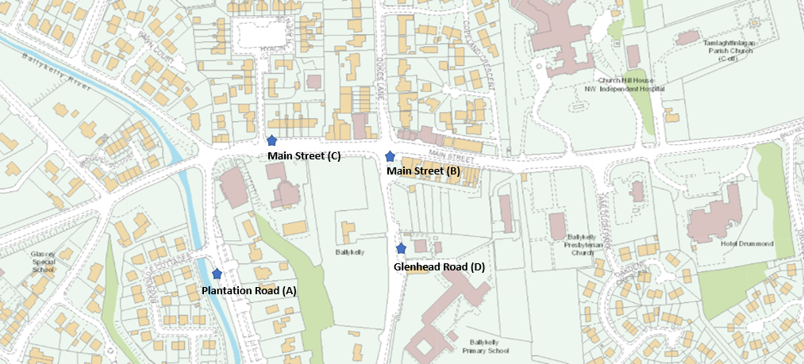

- Ballykelly Monitoring Results – NO₂
Bias adjusted NO₂ concentrations February 2022 – December 2022
Table 3
Monitoring site | Bias adjusted concentration (0.84) µg/m³
Plantation Road, Ballykelly | 5.4
Main Street, Ballykelly | 20.8
Main Street, Ballykelly | 14.1
Glenhead Road, Ballykelly | 15.1

- Annual mean objective level of 40µg/m³
The passive monitoring undertaken has revealed that the annual mean concentration (40ug/m³) for NO₂ was not exceeded at the monitoring locations selected in Ballykelly in 2024.

Diffusion Tubes were deployed in Ballykelly on the following dates:
Table 4: Ballykelly Diffusion Tube Deployment Dates
 | Diffusion Tube Deployment Dates
January | 03/01/2024 | 31/01/2024
February | 31/01/2024 | 06/03/2024
March | 06/03/2024 | 03/04/2024
April | 03/04/2024 | 01/05/2024
May | 01/05/2024 | 05/06/2024
June | 05/06/2024 | 03/07/2024
July | 03/07/2024 | 31/07/2024
August | 31/07/2024 | 04/09/2024
September | 04/09/2024 | 02/10/2024
October | 02/10/2024 | 06/11/2024
November | 06/11/2024 | 04/12/2024
December | 04/12/2024 | 08/01/2025

Recommendation
The Health and Built Environment Department will be seeking to continue with the passive monitoring in Ballykelly.
In conjunction with our duties under the Air Quality legislation, the Environmental Protection Team have been seeking advice from DAERA NI colleagues in the AEQ Team concerning the expansion of monitoring to include mobile monitoring units which may be flexibly deployed within the Borough and expanded to consider other sources of pollutants.

